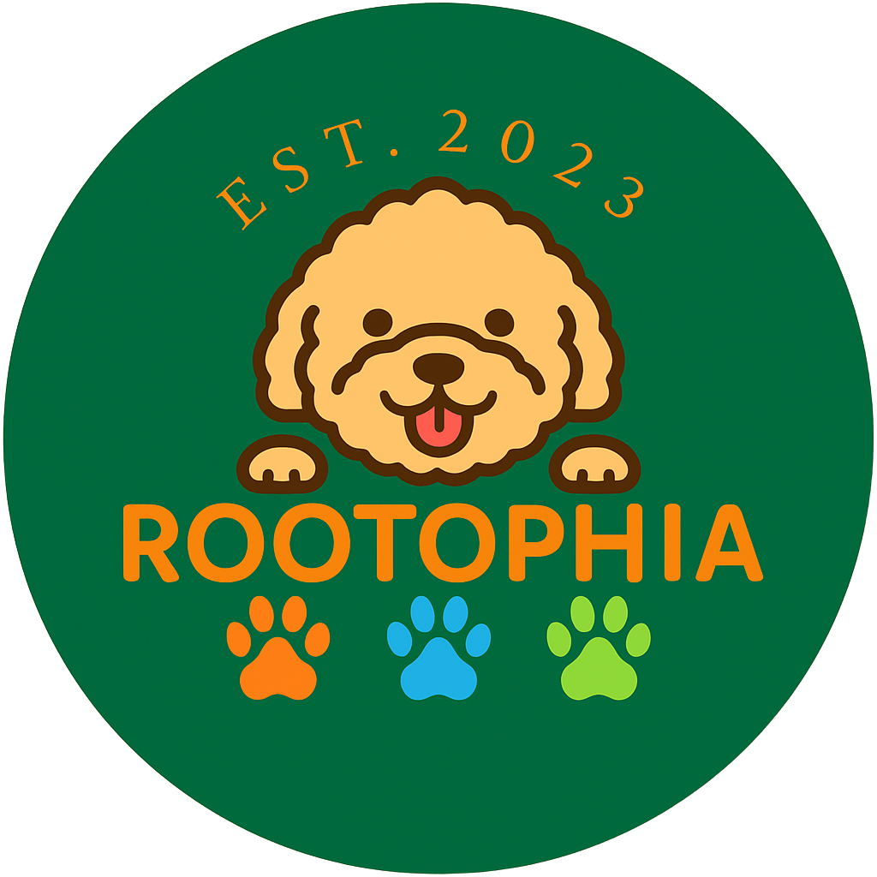
Rootophia Daycare

Welcome Pack & Assessment Form
Required before assessment day
Assessment fee: £10.00 per dog
Phone/WhatsApp: 07523 296365 · Email: rootophiadaycare@hotmail.com
Facebook & Instagram: @rootophia
Document version: 24 Jan 2026

WELCOME
Welcome to Rootophia Daycare! We are delighted to have your dog join our playful, calm and enriching environment. Our team is dedicated to creating a safe, structured, and enjoyable experience for every dog.

ABOUT ROOTOPHIA DAYCARE
Our 17m x 12m daycare facility is designed to offer safety, structure, enrichment and comfort. The space includes:
- Relaxation Area - soft beds, sofas, calming environment.
- Main Play Zone - open play with matched playgroups.
- Puppy / Small Dog Zone - gentle play for smaller or younger dogs.
- Sensory & Enrichment Area - puzzles, sniff games, tunnels.
- Secure Outdoor Yard - fully fenced 6ft perimeter for outdoor breaks.
- Isolation Area - for dogs who need quiet space or have become unwell.

OPENING HOURS
Day | Open | Close
Monday | 7:00 AM | 6:00 PM
Tuesday | 7:00 AM | 6:00 PM
Wednesday | 7:00 AM | 6:00 PM
Thursday | 7:00 AM | 6:00 PM
Friday | 7:00 AM | 6:00 PM
Saturday | 7:00 AM | 6:00 PM
Sunday | CLOSED | CLOSED

PRICES & SESSION TIMES
Service | Time | Price
Assessment (new dogs) | 30-60 minutes | £10.00 per dog
Full Day | 7:00 AM - 6:00 PM | £35.00
AM Half Day | 7:00 AM - 12:00 PM | £23.00
PM Half Day | 12:00 PM - 6:00 PM | £25.00
Weekend Playcare (Saturday) | 7:00 AM - 6:00 PM | £38.00

YOUR DOG’S FIRST DAY
Please ensure your dog:
- Has eaten at least 1 hour before arrival.
- Arrives wearing a secure collar or harness with a name tag.
- Has had a toilet break before entering.
- Brings a lead and any medication (with clear instructions).
- May bring an optional comfort item (e.g., small blanket).
- Does not bring food, treats, bones or rawhide items into daycare.

VACCINATION & HEALTH REQUIREMENTS
To ensure the safety of all dogs in our care, we require the following:
- Full vaccinations up to date (including boosters).
- Puppies must be 2 weeks post final vaccination.
- Flea and worming must be current.
- Dogs must not attend if they have sickness, diarrhoea, coughing or any contagious condition.
- Bitches in season cannot attend.
Vaccination Proof Required for Trial Day: You must bring your dog's vaccination record. Without it, your dog cannot be assessed. Proof can also be sent in advance by emailing a clear photo to rootophiadaycare@hotmail.com.

Intact males - case-by-case
We only allow intact males with chemical castration, and only if we approve them as suitable for daycare. We will carry out extra checks during assessment. Dogs showing humping behaviour, aggression, bullying or unsafe social behaviour will not be accepted into daycare, and some intact males may not be suitable.

OUR DAYCARE ROUTINE
Dogs in our care enjoy a balanced daily structure including:
- Structured Play - supervised playgroups matched by size, temperament and energy.
- Enrichment Activities - tunnels, sniff mats, puzzles, sensory games and confidence-building activities.
- Rest & Calm Time - essential to prevent overstimulation and support wellbeing.
- Outdoor Yard Time - toilet breaks and fresh air within our secure 6ft-fenced yard.
- One-to-One Attention - calm handling, cuddles and gentle support.

ASSESSMENT PROCESS
Your dog’s first visit includes a 30-60 minute assessment which helps us understand:
- How they settle in a new place.
- Their interaction style with staff.
- Their play preferences and energy level.
- Any signs of anxiety, stress, or overstimulation.
This ensures your dog is placed in the right group and cared for safely. If we feel daycare is not suitable, we will discuss alternatives with you.

PHOTOS & SOCIAL MEDIA
With your permission, your dog may appear on our social media pages (Facebook and Instagram). We only share positive, safe and respectful content.

TERMS & CONDITIONS (SUMMARY)
- All bookings must be made in advance.
- Cancellations require 24 hours’ notice where possible.
- Dogs must be fit, well, and not contagious.
- Dogs showing excessive stress or unsafe behaviour may need early collection.
- All collections must be made by an authorised person.
Full terms are included in the signature section at the end of this document.

LATE COLLECTION POLICY
If someone is late to pick up their dog, the following fees apply:
- 15 minutes over: £5.00
- Every 30 minutes (or part thereof): £10.00
Late fees will be automatically taken from your account/card used. Payment must be made before any further sessions. If late pick-ups continue, sessions may be suspended or cancelled.

ASSESSMENT FORM (TO BE COMPLETED BEFORE YOUR DOG’S ASSESSMENT)

1) Owner / Handler Details
Owner full name
Address
Postcode
Mobile number
Email
Preferred contact method | ☐ WhatsApp ☐ Phone ☐ Email

2) Emergency Contact (other than owner)
Name
Relationship
Phone number

3) Dog Details
Dog name
Breed
Sex | ☐ Male ☐ Female
Neutered | ☐ Yes ☐ No ☐ Chemically castrated (proof required)
Date of birth / age
Microchip number
Collar/harness type
Can your dog wear a daycare collar/tag? | ☐ Yes ☐ No
Handling notes (e.g., sensitive areas)

4) Vet & Medical Information
Vet practice name
Vet phone number
Vet address (optional)
Insurance provider (if applicable)
Policy number (if applicable)
Is your dog currently on medication? | ☐ No ☐ Yes (list below)
Medication details / instructions (dose, times, how given):
________________________________________________________________________________
________________________________________________________________________________

5) Vaccination, Flea & Worming
Vaccinations up to date (including boosters) | ☐ Yes ☐ No
Date of last booster
Puppy 2 weeks post final vaccination (if applicable) | ☐ Yes ☐ N/A
Flea treatment up to date | ☐ Yes ☐ No
Worming up to date | ☐ Yes ☐ No
Proof provided | ☐ Vaccination card seen ☐ Photo emailed

6) Diet, Feeding & Allergies
Any known allergies (food/environment)? | ☐ No ☐ Yes (details below)
Diet type (kibble/raw/other)
Feeding times (if relevant)
Can your dog have standard treats? | ☐ Yes ☐ No
Resource guarding around food? | ☐ No ☐ Yes (details below)
Any dietary restrictions?
Allergy / restriction details:
________________________________________________________________________________
________________________________________________________________________________

BEHAVIOUR & SOCIAL HISTORY
This section helps us keep every dog safe. Please be honest and detailed. It will not automatically exclude your dog, but it helps us plan the safest group placement and handling.

7) Around Other Dogs
How does your dog behave around other dogs? | ☐ Friendly ☐ Nervous ☐ Selective ☐ Reactive
Does your dog prefer small or large dogs?
Has your dog been in any fights or caused injury? | ☐ No ☐ Yes (details below)
Any history of growling/snapping/biting? | ☐ No ☐ Yes (details below)
Resource guarding (toys/space/people)? | ☐ No ☐ Yes (details below)
Humping behaviour (dogs/people)? | ☐ No ☐ Yes (details below)
How does your dog cope with busy environments? | ☐ Well ☐ Unsure ☐ Struggles
Any known triggers (e.g., male dogs, doorways, toys)?
Details (fights, aggression, humping, triggers, guarding):
________________________________________________________________________________
________________________________________________________________________________
________________________________________________________________________________

8) Around People
How is your dog with unfamiliar adults? | ☐ Friendly ☐ Shy ☐ Nervous ☐ Reactive
How is your dog with children? | ☐ Great ☐ Limited experience ☐ Not suitable
Any jumping/mouthing behaviour? | ☐ No ☐ Yes (details below)
Any fear of men/women/uniforms? | ☐ No ☐ Yes (details below)
Handling tolerance (paws/ears/coat) | ☐ Good ☐ Sensitive (details below)
Can your dog be safely put on a lead and guided? | ☐ Yes ☐ Sometimes ☐ No
Any history of biting a person? | ☐ No ☐ Yes (details below)
Details (people, children, handling, bite history):
________________________________________________________________________________
________________________________________________________________________________
________________________________________________________________________________

9) Stress, Separation & Noise
Separation anxiety? | ☐ No ☐ Yes (signs/what helps)
Noise sensitivity (thunder/fireworks/barking)? | ☐ No ☐ Yes
Car travel | ☐ Fine ☐ Nervous ☐ Gets car sick
Can your dog rest calmly indoors? | ☐ Yes ☐ Sometimes ☐ No
Crate trained (if relevant) | ☐ Yes ☐ No ☐ Not sure
Anything that helps your dog settle?

10) Training & Routine
Recall | ☐ Reliable ☐ Improving ☐ Not reliable
Lead walking | ☐ Loose lead ☐ Pulls ☐ Reactive
Cues your dog knows (sit, wait, leave, etc.)
Toilet routine
Play style (chase, wrestle, fetch, sniff)
Favourite rewards (toys/attention/treats)
Any restrictions or special instructions for staff?

CLIENT AGREEMENT, CONSENTS & SIGNATURE
Please read carefully and tick each box to confirm. This document forms part of your agreement with Rootophia Daycare.
☐ I confirm that the information provided in this form is accurate and complete to the best of my knowledge.
☐ I understand all dogs must be fully vaccinated, and I will provide proof before the assessment/trial day.
☐ I confirm my dog is fit and well to attend daycare, and I will not bring my dog if they are unwell or contagious.
☐ I understand bitches in season cannot attend daycare.
☐ I understand Rootophia may refuse, suspend or end sessions if a dog shows unsafe behaviour, excessive stress, or is not suitable for group daycare.
☐ I understand and accept the intact male policy: intact males are considered case-by-case, only with chemical castration proof, and may be declined if humping or aggression is present.
☐ I authorise Rootophia staff to use reasonable handling measures to keep dogs safe (e.g., lead, separation, time-out, isolation area when required).
☐ I authorise Rootophia to seek veterinary treatment in an emergency if I cannot be contacted, and I agree to pay any veterinary costs incurred.
☐ I give permission for basic first aid to be administered if required.
☐ Photo & social media permission: ☐ Yes, you may post my dog ☐ No, please do not post my dog
☐ I understand bookings should be made in advance and cancellations require 24 hours’ notice where possible.
☐ I understand the late collection policy and agree that late fees may be taken automatically from the card/account used, and must be cleared before further sessions. Persistent late pickups may lead to suspension/cancellation.
☐ I understand my dog must be collected by an authorised person, and I will notify Rootophia of any changes in advance.
☐ I accept that group daycare involves normal dog play and interactions. Rootophia will manage groups responsibly, but I understand there is an inherent risk of minor injury in dog play.

Name (print): ______________________________________________
Signature: ________________________________________________ Date: ____ / ____ / ______
Emergency contact name: _________________________________ Phone: ______________________

